**ONLINE VOTING SYSTEM**

**Problem Statement:**

To develop an Online Voting System with various defined roles for user as well as admin.

**Description:**

This project is aimed at developing Online Voting System for user. This is a web based application that can be accessed throughout the web. Users can register on the website and after approved by the user, can vote in an election in their area and get result after the election has finished.

**Scope:**

User can register using his current address and after approval vote in the election going on his area. The user can vote during the interval between start time and end time only and after the election ends, get the result of the election.

**Out of Scope:**

User cannot update his address therefore the poll location of user remains same throughout.

**Assumptions:**

1. It is assumed that the admin has verified the details of user before approving him.
2. It is assumed that the admin cannot contest in the election, i.e, register as a nominee.

**Classes:**

**1.User**

**2.Address**

**3.Poll**

**Attributes:**

**1.User**

a.userId : Long

b.userName : String

c.password : String

d.isAdmin : Boolean

e.age: Integer

f. gender: String

g. aadharNo: String

**2.Address**

a.area : String

b.city : String

c.state : String

d.pincode : String

**3.Poll**

a.pollId : Long

b.pollCenter : String

c.startTime : LocalDateTime

d.endTime : LocalDateTime

**Diagrams:**

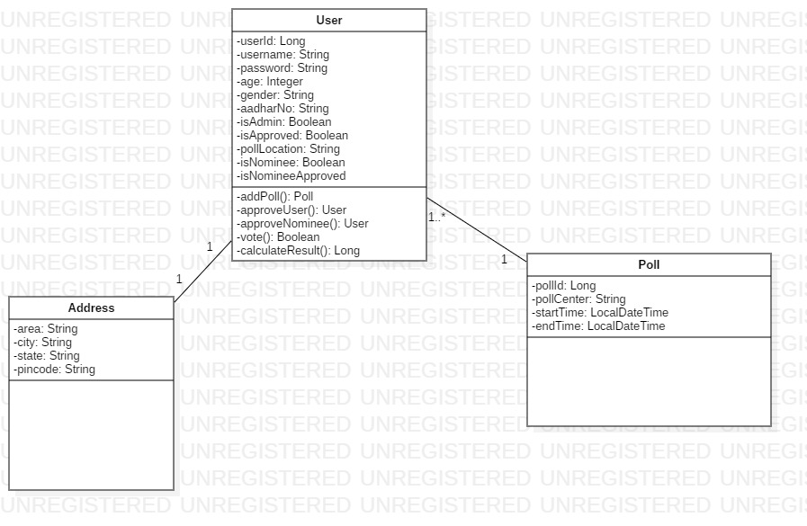

**Class Diagram**

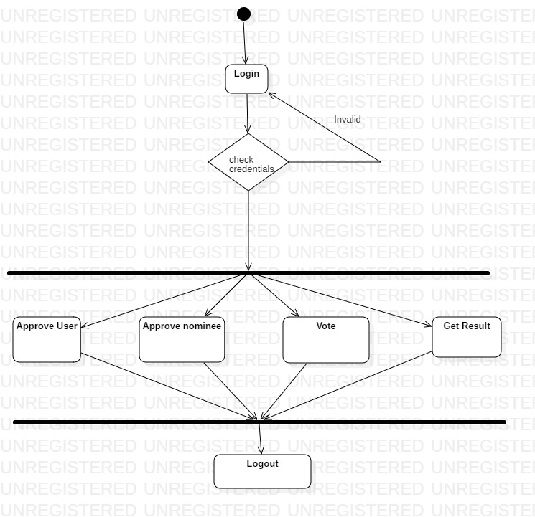

**Activity Diagram of Admin**

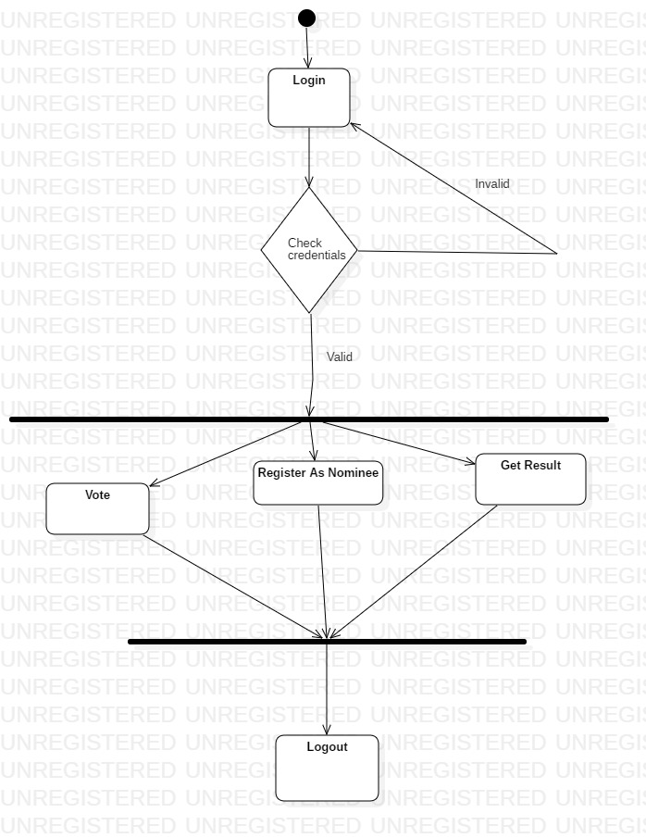

**Activity Diagram of User**

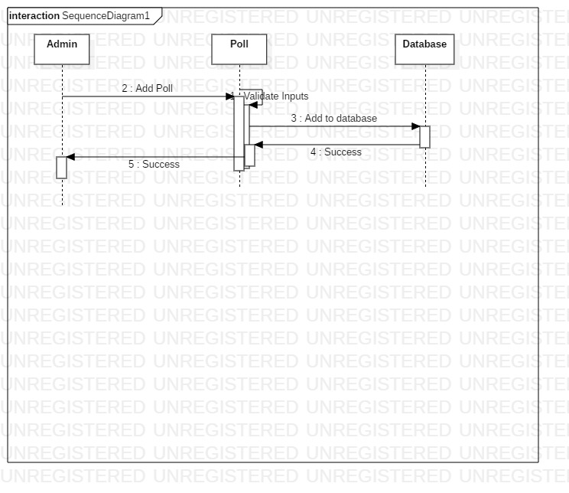

**Sequence Diagram of Poll**

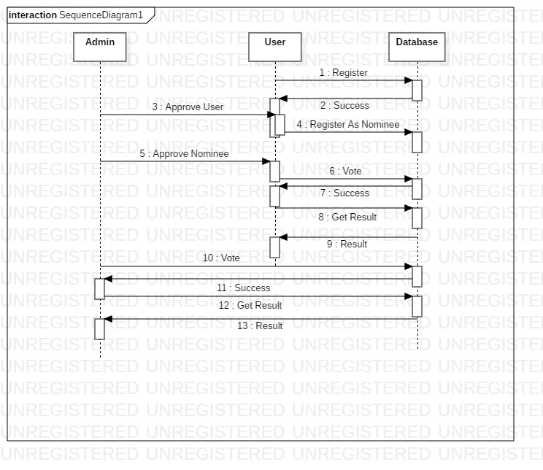

**Sequence Diagram of User**

**Relationship:**

Association exists between User and Address. One user can have only one address. It is a one-to-one relationship.

Association exists between User and Poll. A Poll can contain many users and many nominees. It is a one-to-many relationship.

**Validations -**

1. None of the input can be empty.
2. username shoul be atleast 3 characters long.
3. password should have at least one upper case character, one lower case character, one numeric character and one special character and the length of password should be minimum 8 characters.
4. Age cannot be less than 18 and greater than 100.
5. aadharNo should be 12 digits long and pincode should be 6 digits long.
6. startTime of Poll cannot be in the past and cannot be after 10 days from the current date.
7. endTime of Poll cannot be before the startTime and endTime cannot be more than 10 hours after the startTime.